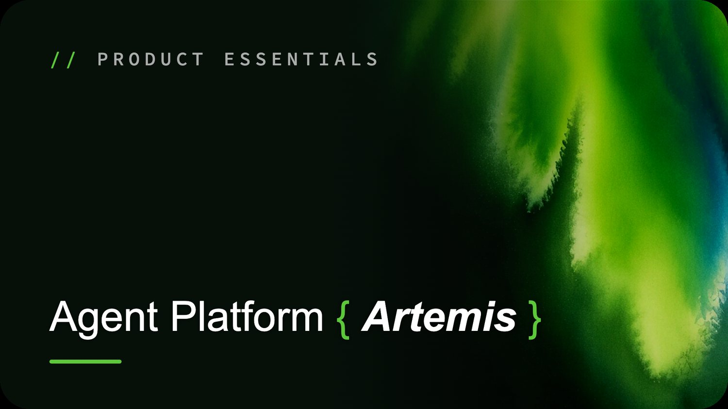

Artemis – Product Essentials
Assignment for Certification

- DESIGN
  - Read the project requirement below and design the SOP.
(the reference markdown SOP file for Banking Project is attached to mail for reference)
- PROJECT
  - Build a new project. Name it as follows:
<yourName>_telecom_assignment_project
Eg.jayantiChakraborty_telecom_assignment_project
- AGENTS
Reasoning Agent - TopUpPlan_Query_Agent
Allows the user to query on TopUp Plans
Endpoints (HTTP Tools):
https://telecom-customer-data.onrender.com/dataTopUp
https://telecom-customer-data.onrender.com/dataTopUp/prepaid
https://telecom-customer-data.onrender.com/dataTopUp/postpaid
Flow Based Agent - UserDataPlan
    - Displays the TopUp plan that matches with the account type of the user
    - Steps
- Ask the user for the Customer ID. Customer ID must start with “CUST” followed by 4 digits. Eg CUST1001, CUST1002
- Fetch the account_type from the customer details. Use the “Customers” table. Endpoint given below.
- Query the TopUp plans table and show the top up plans to the user for the given account type
Endpoints (HTTP Tools)
https://telecom-customer-data.onrender.com/customers
https://telecom-customer-data.onrender.com/dataTopUp/{{account_type}}

Reasoning Agent – SIMIssueAgent
Allows the user to check the SIM card issues
Endpoints (MCP Tools)
https://telecom-mcp.vercel.app/api/sim-issue

- SUPERVISOR
  - Define a Supervisor to route to the agents as per the request of the user.
  - Proper INTENTS categories must be defined for the Supervisor to route the user request to the correct specialized agent
  - Add the On Start welcome message in the Supervisor
  - Make the Supervisor the Start Agent
- GUARDRAILS
  - Add a project-level guardrail to restrict user inputs to the telecom domain. Users must not be allowed to discuss politics, religion, or other sensitive personal beliefs.
  - At an Agent level, define guardrail to stop users from using abusive words
  - Use LLM CHECK for both the guardrails
- EVALS
Set up evaluation assets to validate the assistant experience, response quality, and tool usage across realistic telecom support interactions.
- Personas and scenarios: Create two end-user personas and two realistic scenarios that reflect common telecom customer needs.
- Evaluation criteria: Add LLM judge evaluators to assess response quality and tool correctness.
- Execution: Run the eval suites by combining each persona, scenario, and LLM judge, then review the results for gaps or failures.
- DEPLOYMENT
  - Deploy the project on the web channels and test the end-user experience.
  - Take a screenshot of the conversation as an end user.
- SUBMISSIONS FOR EVALUATION
  - SOP of the project
  - Project Export File. During export, deselect the Evals from the EXPORT LAYERS section.
  - Screenshot of EVALS output
  - Screenshot of end user conversation
  - Transcript file for conversation with the Supervisor demonstrating the multi-agent orchestration
